***PLATTSBURGH HOUSING AUTHORITY***

*** FALL 2014***

**~ ~ TOWN HALL MEETING ~ ~**

**MARK YOUR CALENDARS!!!** A **Family Housing Town Hall Meeting** will be held at the Ted K. Center on **Wednesday, September 24th from 6:30 to 8:00 PM**. This open forum meeting will include representatives from PHA, City Police Department, City Council, and Health Care Agencies. This is a great opportunity for residents to voice their concerns or needs. See you at the Center. **☺**

***FAMILY HOUSING NEWSLETTER***

**In this issue**:

Autumn Activities

Town Hall Meeting

Reminders

What’s for Dinner?

Ted K Center News

Auto-debit for rent payments

***Reminders***

* **Garbage**: All carts are to be placed at the proper location for pick-up prior to 7:00 AM on Tuesdays and returned to the designated storage area by no later than 8:00 AM on Wednesdays. Residents will be charged for not complying with pickup requirements at a minimum charge of $20 plus $3 per bag.
* **Lawns:** Residents who are responsible for maintaining their lawns, and fail to do so, will be charged $35 each time maintenance mows their lawn. Grass clippers, rakes and hand mowers are available to sign out at the Maintenance Shop.
* **Recertification paperwork:** Your recertification is not complete until PHA receives the **Family Choice of Rental Payment** form. This form states whether you elect to pay the flat rate or the rate based on your income for monthly rent. If the form is not returned to the office, you will be charged the flat rate rental fee.
* **Play areas:** Residents are responsible for making sure toys are picked up and stored accordingly after use and not left scattered on lawns or around play areas. In addition, residents need to make sure their children are not discarding garbage or other litter in the common play areas.
* **Wild animals:** Please do not provide food for wild animals. They **are not** your responsibility and the food is attracting skunks to the area.

C:\Program Files (x86)\Microsoft Office\MEDIA\CAGCAT10\j0298897.wmf

**Autumn Activities!!!**

**~ ~ Battle of Plattsburgh ~ ~**

The Battle of Plattsburgh parade will take place on **Saturday, September 13th at 1:00 PM** with fun family events taking place all weekend long. For the complete schedule of events, visit their website at <http://www.champlain1812.com>

C:\Users\Tammy\AppData\Local\Microsoft\Windows\Temporary Internet Files\Content.IE5\VKF9RA2M\MC900329305[1].wmf**Bluegrass Festival C:\Users\Tammy\AppData\Local\Microsoft\Windows\Temporary Internet Files\Content.IE5\VKF9RA2M\MC900329305[1].wmf**

The 3rd Annual Bluegrass Festival will be held at the Clinton County Fairgrounds from **September 11 – 14**. Featured groups include The Gibson Brothers, Foggy River Band, and many others. Campers are welcomed. For more information, visit their website at [www.clintoncountyfair.com](http://www.clintoncountyfair.com)

C:\Users\Tammy\AppData\Local\Microsoft\Windows\Temporary Internet Files\Content.IE5\VKF9RA2M\MC900329305[1].wmf**Cougar Music Festival C:\Users\Tammy\AppData\Local\Microsoft\Windows\Temporary Internet Files\Content.IE5\VKF9RA2M\MC900329305[1].wmf**

A **FREE** music festival will be held at Clinton Community College on **Saturday, September 20th starting at 10:00 AM**. Food and soft drinks will be sold at this all day event. Bring your lawn chairs or blankets and get ready to enjoy this end of summer event!

**\*\*\* B i n g o \*\*\***

Starting September 4th, Bingo will be played on Mondays and Thursdays at Russell H Barnard community room from 2-4 PM. Must be at least 50 years of age and a resident of PHA to play.

*For community events and updates, check out our website at* **http://www.phaplattsburgh.com/**

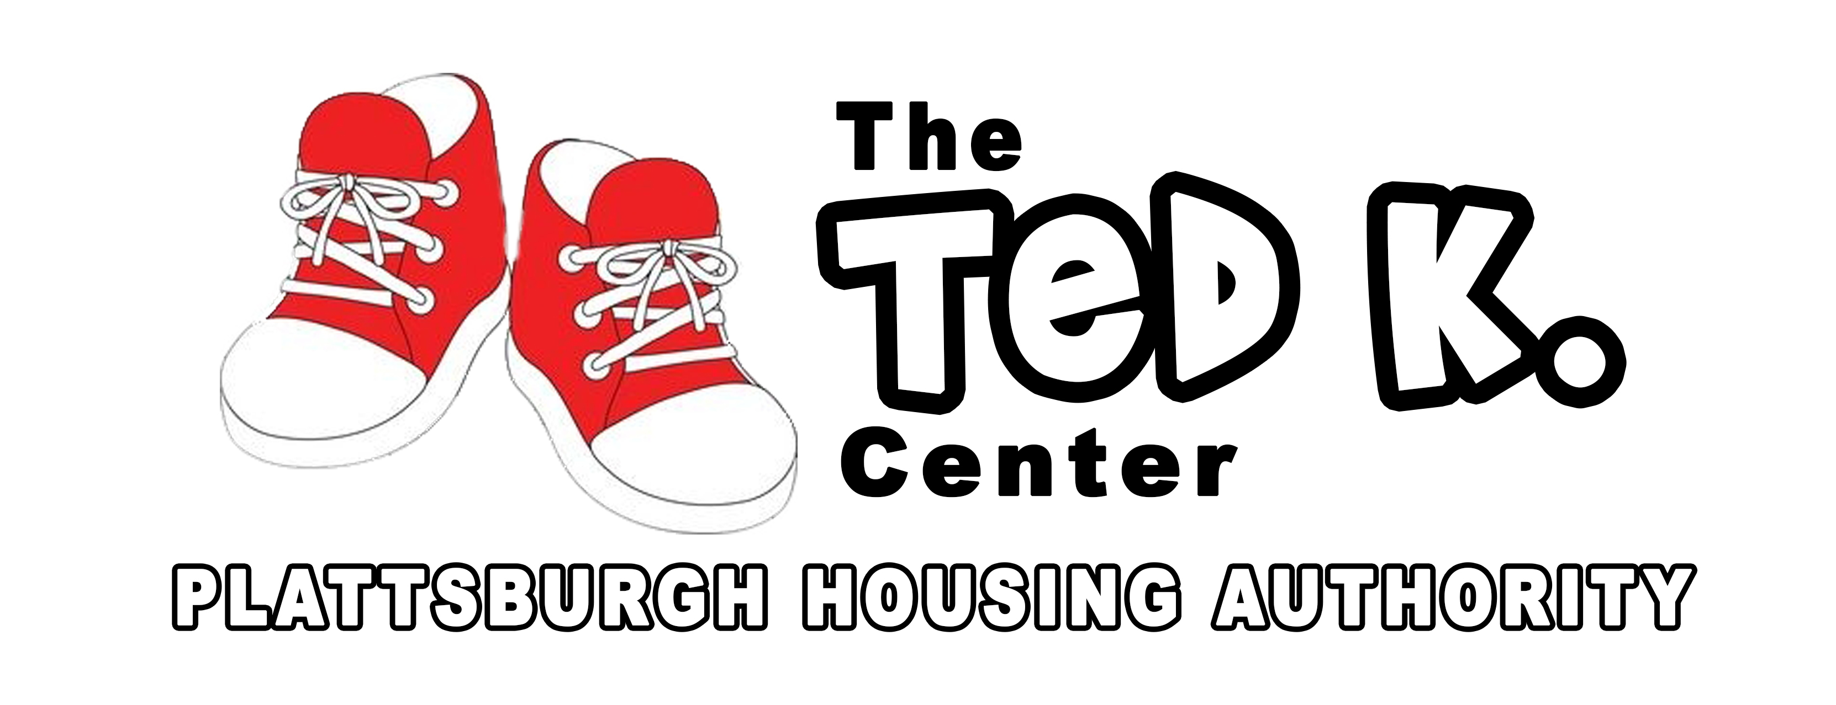

**Ted K. Center Early Childhood Program**

The Plattsburgh Housing Authority’s, 2014/2015 Ted K. Center Early Childhood Program currently has openings. The program will begin on Monday, September 15 and operates throughout the school year **Monday – Friday** from **11:30AM – 2:00PM**. The program is **free** to Housing Authority residents’ ages 3 - 5 who are toilet trained.

Your child will participate in daily activities such as reading and math readiness lessons, arts & crafts, music, story time and group games. A light nutritious snack will be provided each day.

For more information or to register your child please visit the center or call Tom, Virginia or Victoria at **561-7690 ext. 109**.

**Ted K. Center After-School Program**

The Ted K. Center After-School Program will begin on Thursday, September 4, 2014 for PHA resident youth ages 5 (and in Kindergarten) and up. The program will be open Monday- Friday, 2:30pm – 6:00pm throughout the school year. Program youth will participate in daily educational, social and recreational activities. See you at the center!



Looking for an easy way to make sure your rent is paid on-time and avoid paying late fees? Tired of paying for money orders or filling out checks for your rent payments? Our Accounting department has an Authorization Agreement for Direct Receipts (ACH Debits) form that will allow PHA to automatically debit your checking or savings account for the amount owed each month on your account. Please stop by the Administrative Office to fill out the auto-debit form and let us automatically collect your funds in a safe, secure and timely manner!

***What’s for Dinner?***

[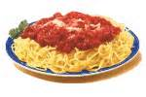](http://www.bing.com/images/search?q=free+clip+art+spaghetti+dinner&qpvt=free+clip+art+spaghetti+dinner&FORM=IGRE#view=detail&id=489766455F6FD515B51447862C76863B550E95FB&selectedIndex=28)

**Roasted Spaghetti Squash with Meatballs**

Fall is a great time to enjoy the harvests by visiting your local farmers’ market and by bringing their products from the farm to your dinner table. This recipe substitutes pasta with squash for a healthier version of a family-favorite comfort food.

**Ingredients: \*** 1 3-pound spaghetti squash (halved and seeded) * 1 pound ground beef * 1 egg, lightly beaten

* 1/3 cup bread crumbs * 2 cloves of minced garlic * 3 14.5-oz cans fire-roasted crushed tomatoes, undrained

* 1 tablespoon dried Italian seasoning * 1 teaspoon sugar * 1 teaspoon crushed red pepper flakes * ½ teaspoon salt * ¼ cup grated Parmesan cheese *cooking spray

**Directions:** Preheat oven to 400 degrees. Lightly coat inside of spaghetti squash with cooking spray. Place squash halves, cut sides down, on a 15x10x1-inch baking pan. Bake about 50 minutes or until squash is soft. Let cool slightly. Use a fork to separate the strands of squash. To make meatballs combine ground beef, egg, bread crumbs, garlic, and 1 teaspoon of the Italian seasoning. Mix then shape into 1-inch meatballs. Lightly coat a very large skillet with cooking spray. Preheat skillet over medium-high heat. Add meatballs to hot skillet; cook until browned, turning occasionally to brown evenly. Add tomatoes, sugar, crushed red pepper (if desired), salt, and the remaining 2 teaspoons Italian seasoning. Bring to boil then reduce heat. Simmer, uncovered, for 7 to 10 minutes or until sauce starts to thicken and meatballs are cooked through. Serve meatballs and sauce over squash. Top with grated Parmesan cheese….enjoy!!

**Nutrition** (per serving; 6 servings): 281 calories; 8 g Fat (3 g Sat; 1 g Mono; 1 g polyunsaturated) 75 mg Cholesterol; 32 g Carbohydrates; 22 g Protein, 6 g Fiber; 809 mg Sodium, 13 g sugar

**$$$$ Auto-debit for rent payments $$$$**